**ANSWERS -** Year 9 term 3 Chemistry Revision Sheet

1. Summary (fill-in-the-blanks):

* The subatomic particles in the nucleus of an atom are the **protons** and **neutrons**. (2 marks: 1 mark each)
* The atomic number represents the number of **protons** in an atom's **nucleus**. (2 marks: 1 mark each)
* The mass number is the total number of **protons** and **neutrons** in the nucleus. (2 marks: 1 mark each)
* Isotopes of an element are the same in the number of **protons** but differ in the number of **neutrons**. (2 marks: 1 mark each)

1. Write the letter of the correct definition beside each term:

1. **B** 2. **D** 3. **E** 4. **C** 5. **A**

1. In the blank spaces below write in the name of the atom part that number is pointing to in the diagram:

6. **Nucleus** 7. **Electron** 8. **Neutron** 9. **Proton**

1. Use the template below to complete a diagram representing the electron arrangement (in the shells shown) for the element listed beside the diagram:

__P

__N

__P

__N

__P

__N

Oxygen

Helium

Calcium

x

x

x

x

x x

x

x x

x x

x x

x x

x x

x x

x

x

x x

x x

x x

x

x

x

Oxygen – 2,6 (8 electrons) Helium – 2 (2 electrons) Calcium – 2,8, 8,2 (20 electrons)

Note: it is the actual number of electrons in each shell that is important. They can be paired, like above or randomly placed

1. If an atom has the same number of protons and electrons, its charge is:

**(c) neutral** (1 mark)

1. Compared to the protons and neutrons, the mass of an electron is:

**(d) almost zero** (1 mark)

1. Define the following terms:

* **Atomic number**: The number of protons in the nucleus of an atom. (1 mark)
* **Mass number**: The total number of protons and neutrons in the nucleus of an atom. (1 mark)
* **Isotope**: Atoms of the same element with the same number of protons but different numbers of neutrons. (1 mark)

1. How many protons are found in:

* a. **¹²C**? **6 protons**
* b. **¹³C**? **6 protons**
* c. **¹4C**? **6 protons** (1 mark)

1. How many neutrons are found in:

* a. **¹²C**? **6 neutrons**
* b. **¹³C**? **7 neutrons**
* c. **¹⁴C**? **8 neutrons** (1 mark)

1. How many electrons are found in:

* a. **¹²C**? **6 electrons**
* b. **¹³C**? **6 electrons**
* c. **¹⁴C**? **6 electrons** (1 mark)

1. Use the periodic table to complete the following table:

* **40K**
  + Symbol: **K**
  + Atomic Number: **19**
  + Mass Number: **40**
  + Number of Protons: **19**
  + Number of Neutrons: **21** (40 – 19)
  + Number of Electrons: **19**
* **32P**
  + Symbol: **P**
  + Atomic Number: **15**
  + Mass Number: **32**
  + Number of Protons: **15**
  + Number of Neutrons: **17** (32 - 15)
  + Number of Electrons: **15**
* **65Zn**
  + Symbol: **Zn**
  + Atomic Number: **30**
  + Mass Number: **65**
  + Number of Protons: **30**
  + Number of Neutrons: **35** (65 - 30)
  + Number of Electrons: **30**
* **⁸¹Br**
  + Symbol: **Br**
  + Atomic Number: **35**
  + Mass Number: **81**
  + Number of Protons: **35**
  + Number of Neutrons: **46** (81 - 35)
  + Number of Electrons: **35**
* **²³⁵U**
  + Symbol: **U**
  + Atomic Number: **92**
  + Mass Number: **235**
  + Number of Protons: **92**
  + Number of Neutrons: **143** (235 - 92)
  + Number of Electrons: **92**

1. The following statement contains an error. Rewrite the statement so that it is more correct:

* **An ¹⁸O atom contains the same number of protons and electrons as a ¹⁶O atom, but has a different number of neutrons.** (1 mark)

1. Describe what the ¹²C and ¹⁴C isotopes of carbon have in common and how they are different:

* **Common**: Both have 6 protons and 6 electrons. (1 mark)
* **Different**: ¹²C has 6 neutrons, while ¹⁴C has 8 neutrons. (1 mark)

1. In the diagram below, there are three types of radioactive radiation shown. Identify each of the radiations as being alpha, Beta, or gamma radiation:

* Radiation type A = **Gamma** (1 mark)
* Radiation type B = **Beta** (1 mark)
* Radiation type C = **Alpha** (1 mark)

1. Radon, iodine, and cobalt all have radioactive isotopes. The isotopes each undergo radioactive decay according to the nuclear equations shown below. Use the clues in the equations below to complete the missing atomic and mass numbers, and identify the type of radiation being emitted in the equation:

* ${}_{88}^{226}{Ra} → {}_{86}^{222}{Rn} +$ ${}_{2}^{4}{He}$: The radiation emitted is **Alpha**. (2 marks: 1 mark for the missing numbers, 1 marks for correct type of radiation)
* ${}_{53}^{131}I → {}_{54}^{131}{Xe} + {}_{-1}^{0}β$ The radiation emitted is **Beta**. (2 marks: 1 mark for the missing numbers, 1 marks for correct type of radiation)
* ${}_{27}^{60}{Co} → {}_{28}^{60}{Ni} + {}_{-1}^{0}β$ The radiation emitted is **Beta** and **Gamma rays**. (2 marks: 1 mark for the missing numbers, 1 marks for correct type of radiation)

1. Match the following models/discoveries/theory/law with the related person/experiment:

* Idea of the atom as indivisible: **d. Democritus** (1 mark)
* Plum Pudding Model: **c. Thompson / Discovery of the electron** (1 mark)
* Nuclear Atom – atoms have a very small dense nucleus: **a. Rutherford / Gold foil experiment** (1 mark)
* Different elements are made from different atoms which can combine to make other matter: **e. John Dalton** (1 mark)
* Electrons in an atom exist in shells: **b. Neils Bohr / emission spectra** (1 mark)

1. In the diagram on the right draw the path that alpha, Beta, and gamma radiation would take in the electric field:

* Alpha radiation: **Curves towards the negative plate** (1 mark)
* Beta radiation: **Curves towards the positive plate** (1 mark)
* Gamma radiation: **Travels straight** (1 mark)

1. In an experiment with lead sheets:

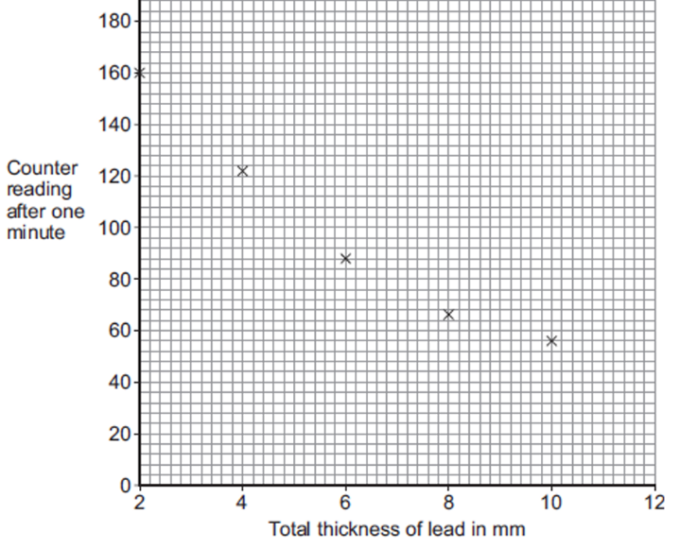

(i) **Draw a line of best fit**: Draw a curved line that best represents the data points. (1 mark)

(ii) **Identify the trend**: As the thickness of the lead increases, the counter reading decreases. Example: If lead thickness increases from 2 mm to 6 mm, the counter reading drops from 160 to 90. (2 marks: 1 mark for stating the trend, 1 mark for supporting data)

(iii) **Estimate the reading for 12 mm lead**: answer depends on line of best fit. 52 counts (1 mark)

(iv) **What type of radiation was emitted from the radioactive source? Explain your answer:**

**Gamma radiation**. **Explanation**: gamma radiation is more penetrating than alpha and beta radiation. Only gamma rays would pass through several mm of lead sheet. (2 marks: 1 mark for identifying the radiation type, 1 mark for explanation)

(v) **Independent variable**: **Thickness of lead sheets** (1 mark)

(vi) **Dependent variable**: **Counter reading (amount of radiation detected)** (1 mark)

(vii) **Controlled variable**: **Distance from the radioactive source, type of lead used, or time of measurement** (1 mark)

1. The table below shows how the count rate from a radioactive source changes with time. Use the table to calculate the count rate after 240 seconds. Explain your reasoning:

* **Calculation and reasoning**: 50 counts. The data clearly indicates a half life of 80 seconds (in 80 secs, the count went from 400 to 200. Therefore 240 seconds therefore represents 3 half-lives (3 x 80). The original count of 400 multiplied by ½ x ½ x ½ = 50 counts. (2 marks: 1 mark for the correct count rate, 1 mark for explanation)

1. The graph shows how, in a sample of air, the number of radon-222 nuclei changes with time:

* (a) **Find the half-life of radon-222**: 3.8 days. The initial count was 800 and after one half life the count would be 400, which occurred after 3.8 days (2 marks: 1 mark for correct value, 1 mark for showing working)
* (b) **Estimate the amount of time for the sample to reduce to 100 nuclei**: 11.4 days, 3 half lives. To get to 100 nucei, the initial 800 is cut in half three times; 800 x ½ =400 x ½ =200 x ½ = 100. Each half life is 3.8 days, and three lots of 3.8 is 11.4 days (2 marks: 1 mark for calculation, 1 mark for showing work)

1. For each of the following chemical reactions, identify the reactants and the products, and balance the reaction:

a) **N₂ + 3H₂ → 2NH₃**

* + Reactants: **N₂, H₂**
  + Products: **NH₃** (2 marks)

b) **2P₂O₃ → P₄ + 3O₂**

* + Reactants: **P₂O₃**
  + Products: **P₄, O₂** (2 marks)

c) **2AgNO₃ + Cu → Cu(NO₃)₂ + 2Ag**

* + Reactants: **AgNO₃, Cu**
  + Products: **Cu(NO₃)₂, Ag** (2 marks)

d) **CH₄ + 2O₂ → CO₂ + 2H₂O**

* + Reactants: **CH₄, O₂**
  + Products: **CO₂, H₂O** (2 marks)

e) **MgF₂ + Li₂CO₃ → MgCO₃ + 2LiF**

* + Reactants: **MgF₂, Li₂CO₃**
  + Products: **MgCO₃, LiF** (2 marks)

1. For each of the chemical reactions described below, identify the reactants and the products, and write a balanced chemical equation:

a) Solid calcium chloride (CaCl₂) reacts with water to produce hydrogen chloride gas (HCl) and calcium oxide (CaO).

* + Reactants: **CaCl₂, H₂O** (1 mark)
  + Products: **HCl, CaO** (1 mark)
  + Balanced equation: **CaCl₂ + H₂O → 2HCl + CaO** (1 mark)

b) Liquid ethanol (C₂H₅OH) burns in oxygen gas (O₂) to produce water and carbon dioxide gas (CO₂).

* + Reactants: **C₂H₅OH, O₂** (1 mark)
  + Products: **H₂O, CO₂** (1 mark)
  + Balanced equation: **C₂H₅OH + 3O₂ → 2CO₂ + 3H₂O** (1 mark)

c) Lithium carbonate (Li₂CO₃) reacts with hydrochloric acid (HCl) to produce water, carbon dioxide gas (CO₂), and lithium chloride (LiCl).

* + Reactants: **Li₂CO₃, HCl** (1 mark)
  + Products: **H₂O, CO₂, LiCl** (1 mark)
  + Balanced equation: **Li₂CO₃ + 2HCl → 2LiCl + H₂O + CO₂** (1 mark)

1. State the law of conservation of matter (Mass) and explain what it means in terms of the reaction shown below:

* **Law of conservation of matter**: Matter cannot be created or destroyed in a chemical reaction; it can only change forms. (1 mark)
* **Reaction**: Si + O₂ → Si₂O₆
* Explanation: In this reaction, the number of each type of atom (Si and O) on the reactant side must equal the number on the product side, illustrating that mass is conserved. This means a balanced equation would look like 2Si + 3O₂ → Si₂O₆ (1 mark)